[Reducing Risk of Malaria with Solar Powered Device; an Innocentive.com challenge]

LTP (Lure, Trap, Poison) - ANTI-MALARIA DEVICE (SOLAR POWERED)

Introduction:
The proposed device (see diagram) consists of one main “lure” feature (which can be variously accomplished), utilizing the known mosquito attractant CO2, and two secondary features: 1 trap component, 1 poison component. The concept was designed to be maximally effective, relatively low-tech, flexible, and with features/secondary components that can be procured / replaced locally or with minimal construction effort.

The LURE: The lure here is the gas carbon dioxide (CO2). Activated CO2 receptors in female mosquito neurons guide the mosquito towards its target (a warm-blooded, CO2 exhaling animal). Thus, on a basic, attractant level, the proposed device offers competition to sleeping humans for mosquito attention.

The device would consist of a simple, low-powered, plastic pump structure within a (refillable) CO2 chamber or compartment.* (see diagram for one version of this set up). The pump would be controlled by small springs attached to battery powered (recharged by solar panels) actuators. The pump chamber is itself housed within a second, micro-perforated shell, which controls/limits the release of the CO2 gas into the air. The pump’s function is to regularly pump into the local environment a steady CO2 “cloud” to continuously attract female mosquitoes (note: the total amount of CO2 pumped is insufficient to cause harm to sleeping people).

The optimal location/placement (including elevation) of the device (relative to occupants) would need to be determined. As designed, the device rests upon a tripod configuration, a few inches above the ground or resting surface.

*The gas source was originally conceived of as a CO2 cartridge (pressurized), but this was changed upon consideration of the danger from cartridge explosions (exception being a CO2 cartridge that is less pressurized, but could provide enough CO2 for 10 hours).

Regarding CO2 utilization and dispersal - two (cheap/practical) possibilities:

1] A compressed tablet of CO2 (combined with water soluble “fixer”; example: the old ‘Acti-bath’ tablets that you could add to your bath water for a “more relaxing bath”), placed by hand into the inner chamber which is designed to hold water (perforations do not cover the entire, outer housing). In this case, the pump might not be needed (as can pass through the perforated outer shell naturally), however, the purpose of the pump is to provide that steady stream of CO2 molecules sufficient to attract the mosquitoes. Depending upon the design of the tablet, a second or third tablet may have to be inserted in the device over the course of the evening.

2] Orally refilling the central chamber via a one-way valve/mouth piece (see design diagram); this could be also facilitated through balloons (filled up by ordinary means) which provide a larger supply of CO2, and which can then be periodically attached to the valve end…or a combination of possibilities 1] and 2].

The TRAP component of the LTP is as follows:

A (micro-perforated) tube-like “shell” made of standard fly-strip material (ultra-sticky resin coated paper) which can be easily put into place over and around the central chamber (note: the sticky shell, made of paper and resin, is open at one end only (the base), the other, top end sits atop the central housing . The sticky paper would have a small tab attached for easy handling and placement. Mosquitoes, attracted by the CO2 effluent, would land on the shell and become stuck, permanently. As the shell becomes covered with stuck insects, it can be burned or discarded.

The POISON component is as follows:

At the base of the CO2 chamber housing is a shallow trough that can be filled with some type of animal blood (rat, pig, etc.; blood would need to be saved periodically for this purpose) with two additives:

- an anti-coagulant (e.g., heparin or natural analog derived from leeches, e.g.)
- a toxin extract derived from chrysanthemum flowers (as noted in the challenge notes)

The troughs (arranged in a triangular fashion around the central chamber, see diagram) are heated via the stored energy in the rechargeable batteries, thus maintaining “warm bloodedness” (relative mammalian blood temperature). Note: blood can also be diluted).

This (poison) feature was added to offer a secondary method of insect control.

DESIGN NOTE:
In its original conception, the device utilized a thin wire mesh shell over the central chamber which is/was electrically conductive (the bottom of the wire mesh shell would make contact with a small electrode (connected to the battery power source), thus “zapping” the insects that landed on it (attracted by the CO2). However, this method was changed due to consideration of the amount of electric potential need to kill (“zap”) the mosquito, and uncertainty as to whether this potential could be realized by the batteries, as well as how long this could last without draining batteries too soon.

ADDITIONAL NOTES:
The diagram is a fairly specific but also partly conceptual design; the exact mechanism of the pump [actuator-spring type set up) is not illustrated in detail (no prototype has been built to test this).

The entire housing could be made from alternative materials (other than oil-based plastic) such as polysalene (starch) or a fructose based hydro-carbon polymer (e.g., hydroxy-methyl-furfurol). The key factor would be sufficient structural strength to hold under some pressure from the gas, and be durable for 5 years.

The addition of a small lighting source (very low wattage, or possibly an LED) could augment the attraction potential of the lure, or, at least act as a warning beacon to prevent accidental stepping on (in the case of ground placement).

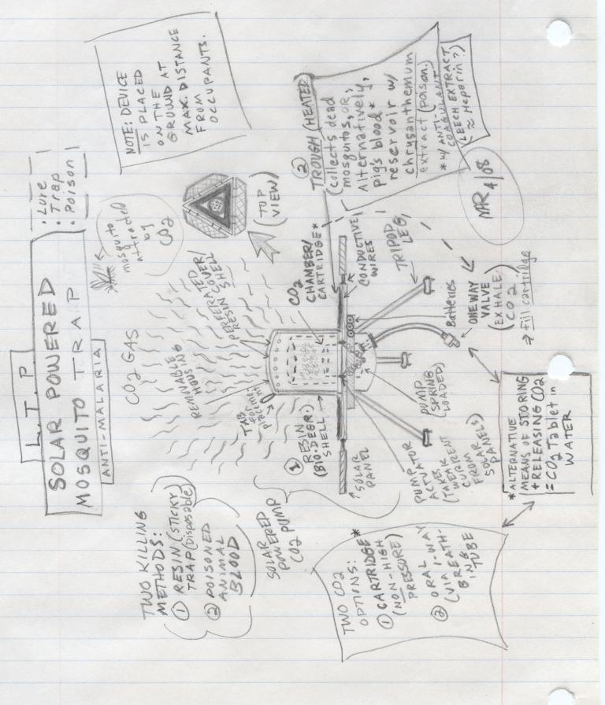
SHAPE \* MERGEFORMAT

